### Style Hierarchy

With the various flavors of [styles](styles.docx) available (see each of the subclauses below), multiple style types can be applied to the same content within a file, which means that properties must be applied in a specific deterministic order. As with inheritance, the resulting formatting properties set by one [type](type.docx) can be unchanged, removed, or altered by following types.

The following [table](table.docx) illustrates the order of application of these defaults, and which properties are impacted by each:

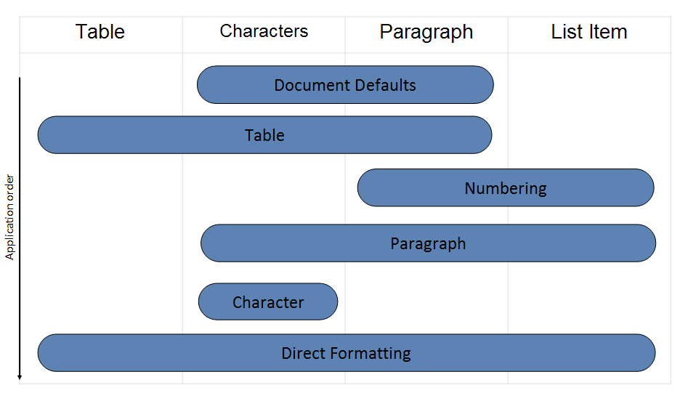

This process can be described as follows:

* First, the document defaults are applied to all runs and paragraphs in the document.
* Next, the [table](table.docx) style properties are applied to each [table](table.docx) in the document, following the conditional formatting inclusions and exclusions specified per table.
* Next, numbered item and paragraph properties are applied to each paragraph formatted with a [numbering](numbering.docx) style.
* Next, paragraph and run properties are applied to each paragraph as defined by the paragraph style.
* Next, run properties are applied to each run with a specific character style applied.
* Finally, we apply direct formatting (paragraph or run properties not from styles). If this direct formatting includes [numbering](numbering.docx), that [numbering](numbering.docx) + the associated paragraph properties are applied.